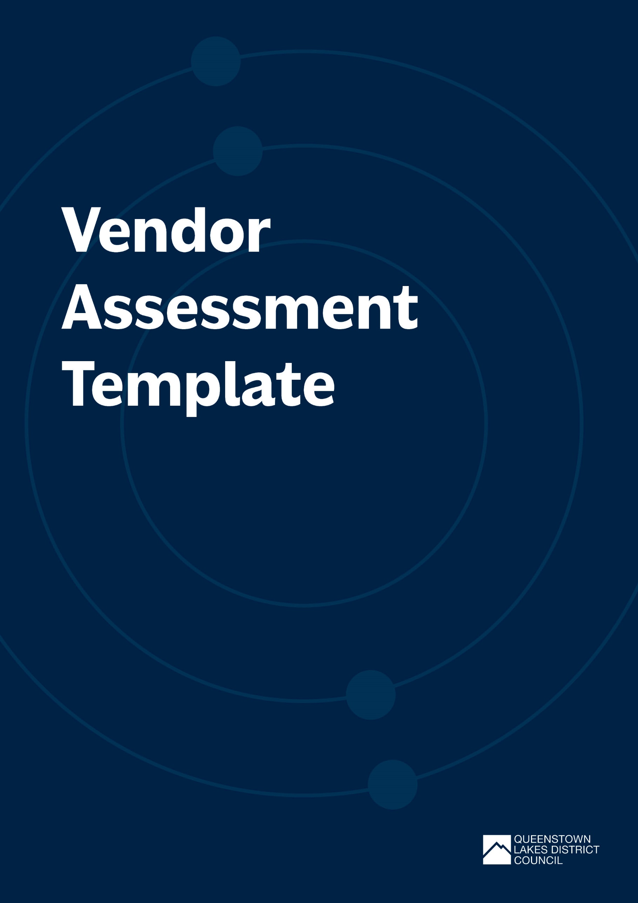

Vendor Assessment Template
Use this template to help keep track of the waste produced and managed by vendors and key GHG emissions before, during and after your event.
Vendor Assessment
Vendor Name:
Key Contact:
Description of saleable items or giveaways:
e.g. food/drinks, merchandise items
Types of waste generated by vendor:
Key GHG emission sources
BEFORE EVENT | YES | NO | COMMENT
Does the vendor understand your event objectives and targets?
Does the vendor understand your waste and reuse infrastructure systems?
Has the vendor outlined how they plan to meet event waste minimisation goals?
Has the vendor outlined how they plan to meet your event emission reduction goals?
DURING EVENT | YES | NO | COMMENT
Does the vendors packaging and/or serveware meet event requirements?
Does the vendor have an appropriate in-stall sorting system for the waste produced?
Is the vendor incentivising or promoting reusables?
THE END OF EVENT | YES | NO | COMMENT
Is the vendors booth/stall free from waste and litter?
Has the vendor provided any required feedback on the waste and reuse initiatives?
Has the vendor provided any feedback on the GHG reduction initiatives?
Any additional feedback:

