|  |  |
| --- | --- |
|  | Tauranga Traffic Operations Centre |
|  | Requirements for SCATS Operators |
|  | Document No.TTOC-13  November 2017 |
|  |  |

Table of Contents

Table of Contents

1. Introduction 3

1.1 Purpose 3

1.2 Who Should Use This Document? 3

2. Role and Responsibilities 5

2.1 SCATS Operator Role 5

2.1.1 Active Monitoring 5

2.1.2 Passive Monitoring 6

2.2 SCATS Operator Responsibilities 6

3. Fault Reporting Procedures 8

3.1 Hardware 8

3.2 Communication 8

3.2.1 Moxa/serial devices 9

3.3 Power Supply 10

4. SCATS 11

4.1 Notes in SCATS 11

4.1.1 **GUI Notes**: you can’t use “ctrl+T” for notes, therefore enter line as “Date, Initials – entry” 11

4.1.2 **Site notes** have been divided up into three categories with headings on each panel: 11

4.2 Software / CIS 12

4.2.1 Standards for TTOC: 12

4.2.2 CIS > SCATS process 12

4.2.3 Site Details 12

4.2.4 Scats data 13

5. Documentation 14

5.1 File structures 14

**Document History and Status**

|  |  |  |  |  |
| --- | --- | --- | --- | --- |
| **Revision** | **Date** | **Prepared By** | **Authorised By** | **Description** |
| Final | May 2013 | Martin Huang | Haydn Wardley | Final |
| B | August 2016 | Haydn Wardley | James Wickham | Draft – added Eltima to 3.2; |
| C | November 2017 | Haydn Wardley | James Wickham | Added Scats notes sections and CIS |
|  |  |  |  |  |
|  |  |  |  |  |
|  |  |  |  |  |
|  |  |  |  |  |

**Disclaimer**

The concepts and information contained in these above documents are their subsequent amendments or replacements are the property of the participants of the Tauranga Traffic Operations Centre (TTOC). No use of copying of these documents in whole or in part is allowed without the written permission of Tauranga Traffic Operations Centre.

Every attempt was made to ensure that the information in these documents was correct at the time of publication. Any errors should be reported as soon as possible so that corrections can be issued. Comments and suggestions for future editions are welcome and periodical reviews are undertaken on a regular basis. Users of these documents must ascertain themselves that they obtain the latest versions as valid references.

# Introduction

The Tauranga Traffic Operations Centre (TTOC) is responsible for all traffic signals operations in the Tauranga and Western Bay region from installation through to maintenance.

All intersections in Bay of Plenty for local and NZTA RCA’s are managed via TTOC.

This document is designed to assist all interested parties to understand how the TTOC functions and the standards that have been adopted to ensure a consistent approach is maintained when designing and installing traffic signals.

## Purpose

The purpose of this document is to give an understanding of the TTOC requirements when monitoring SCATS operations during the day and specify particular tasks undertaken as the daily operator.

## Who Should Use This Document?

This document should be used by consultants or contractors delegated by TTOC to operate SCATS and associated systems to monitor traffic flows along signalised intersections on behalf of Councils or NZTA in the Tauranga and Western Bay regions.

Glossary of terms

|  |  |
| --- | --- |
| **AS / NZ** | Australian Standard / New Zealand Standard |
| Active Traffic Management System (**ATMS**) | Technology that provides information to road users by means of Variable Message Signage. |
| **Controller** | The equipment (including the housing) that switches power to signal lanterns and controls the duration and sequence of signal displays as defined by the controller personality. |
| Controller Information Sheets (**CIS**) | A hard copy of the information used to make a Controller Personality that is contained within the PROM. |
| Controller Personality | The unique program stored in the PROM, which configures the controller to the specific operational design of the intersection. |
| **CCTV** | Closed Circuit Television. |
| **DP** Number | Data Private Number (Prefix assigned to phone line number) |
| **PCMCIA** Card | A computer card containing the controller personality information housed in the TSC/4 compliant controller. In this document PROM refers to either a PROM or a PCMCIA card. |
| **PROM** | A computer chip containing the controller personality information housed in the TSC/3 compliant controller. In this document PROM refers to either a PROM or a PCMCIA card. |
| **FSL** | From Stop Line, measurement used for distance from start of detector loop. |
| **ICP** Number | Installation Connection Point Number (for electricity power meter). |
| Intelligent Transport Systems (**ITS**) | Refers to various systems like Scats, CCTV, VMS and ATMS systems that provide and add [information and communications technology](http://en.wikipedia.org/wiki/Information_and_communications_technology) to [transport](http://en.wikipedia.org/wiki/Transport) [infrastructure](http://en.wikipedia.org/wiki/Infrastructure). |
| **KJB** | Kerbside Junction Box to access services, for example detector loop feeders. |
| **NIA** | New Installation Acceptance. |
| Road Asset and Maintenance Management (**RAMM**) | An Internet accessible system that stores the Traffic Signal assets. Also records the activity of the Maintenance Contractors by the logging of faults as Dispatches and their completion by the Contractors. Contractors’ claims are generated from the system at each month end. |
| **RCA** | Road Controlling Authority. |
| Road Transport Authority (**RTA**) of New South Wales (**NSW**) | The Authority that is accepted as the basis for the TTOC standards and for product approval. |
| **SAT** | Site Acceptance Test, commissioning check list. |
| Sydney Coordinated Adaptive Traffic System (**SCATS**) | A fully adaptive area wide control system for traffic signals that is linked to all of the controllers via telecom lines or fibre optics. |
| **NZTA** | New Zealand Transport Agency. |
| **TMU** | Auckland Traffic Management Unit |
| Tauranga Traffic Operations Centre(**TTOC**) | Organisation tasked with managing the traffic signals and the ITS systems for local roads and State Highways Bay of Plenty by monitoring SCATS and CCTV. |
| Vehicle Activated Sign (**VAS**) | VAS is a generic term for a type of road [traffic sign](http://en.wikipedia.org/wiki/Traffic_sign) which displays a message conditional upon the presence, or speed, of a [road vehicle](http://en.wikipedia.org/wiki/Category:Road_vehicles). |
| Variable Message Sign (**VMS**) | An electronic traffic sign often used to display a message or picture, often the sign display is changeable and dynamic. |
| **Win Traff** | A software programme used to check the controller information by testing the software of the controller personality. |

# Role and Responsibilities

## SCATS Operator Role

The role of a SCATS Operator is to monitor the SCATS system and Tauranga’s traffic signals to identify both operational and hardware faults, manage faults, deal with complaints, process SCATS data and produce reports at the TTOC.

There are three key principal objectives of a SCATS Operator to achieve as the following:

1. Efficient operation of traffic control systems through monitoring of routine traffic operations, operational faults and maintenance status, special events, planned closures and incidents response planning
2. Monitoring, diagnosing and reporting issues in relation to traffic engineering programmes
3. Providing an excellent communication channel and information source to Tauranga City Council colleagues and public road users.

As part of point 1 above, the SCATS Operator will monitor the system actively and passively. The following sections outline the two forms of monitoring undertaken.

### Active Monitoring

Active monitoring is undertaken by the SCATS Operator during peak periods, being 7:30am to 9am, 11am to 1pm and 3pm to 5:30pm, respectively. The purpose of undertaking active monitoring is to identify issues relating to unusual congestion and intersection operation during the peak traffic times with the aim to “actively” attend to live traffic issues. Through active monitoring, key commuter intersections and routes will be monitored through the peaks using CCTV cameras and technical tools such as “Unusual Congestion Monitor” and SCATS. Using SCATS the operator then adjusts the system to relieve congestion at the problematic intersections.

Active monitoring also involves clearing obvious alarms including Major alarm, Fallback, etc. as well as identifying maintenance jobs such as Detector alarm, Lamp fault, etc. and then generate jobs in TTOC asset management system for the contractor to action. An example of SCATS Access monitoring window and unusual congestion monitor windows are shown below.

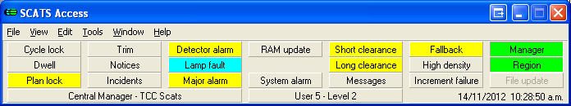

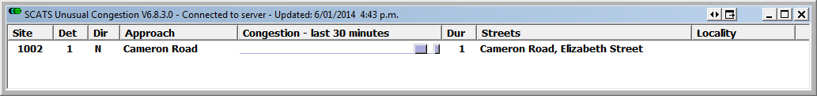

### Passive Monitoring

Passive monitoring is to be undertaken at off-peak times throughout the day. The purpose of undertaking passive monitoring is to identify faults and/or issues that are not immediately apparent or the SCATS system has not registered. These issues could be unusually long or short phases, queues and general unusual intersection operation such as high degree of saturation (DS) during off-peaks.

It is also an opportunity to do “housework” on the SCATS system such as clearing old notes, identifying graphic errors and reviewing the overall setup of intersections.

However, even while the SCATS Operator is passively monitoring, the SCATS alarms should still be watched closely for logged faults as they occur.

## SCATS Operator Responsibilities

The core responsibilities of a SCATS Operator are:

1. Temporary Traffic Management

Provide assistance to traffic management contractor by adjusting SCATS settings, applying locks and trims and activating schedules, in order to alleviate limitation of an intersection capacity and efficiency due to specific site arrangements such as lane closures. Any TMP around traffic signals require a pre setup phone call to the TTOC duty Engineer, this includes lane changes and opening of road, unless otherwise arranged in the initial phone call. Work with the Road Corridor team as required.

1. Faults

The SCATS Operator will identify and log faults to TTOC asset management system with the relevant contractor and report on the various intersections hardware, software and CCTV faults.

1. Complaints

When complaints are received the SCATS Operator is to investigate the complaint and action as appropriate or pass back to the relevant TTOC staff requesting further investigations, e.g., onsite monitoring.

1. Communications (not hardware comms/faults)

The SCATS Operator is to maintain communication with various contract managers and engineers in relation to intersection and network performance, hardware or software faults, operational issues and complaints.

1. Special Events

When special events are planned and being managed by the Police or STMS, the SCATS Operator is to provide assistance to these parties to manage the traffic using SCATS system.

1. Administration

SCATS Operator is also expected to keep accurate and detailed record of daily operational notes for future reference. Any variations or discrepancies identified need to be reported to TTOC staff for clarifications. See section 6 for details on SCATS record keeping and folder structures on the server.

When requests for data are received and approved by TTOC, the SCATS Operator is to process the data request and respond to the initial request.

# Fault Reporting Procedures

SCATS Operator needs to follow the procedures when reporting respective faults in appropriate categories.

## Hardware

These include potential faults on the controller, lamp outages or twisted lanterns, etc. should be reported to traffic signal contractor (currently Traffic System Ltd at 07-5759595) and recorded in the asset management system later on.

## Communication

All communication errors should be reported to TTOC Traffic Signals Specialist [Richard.Eaton@tauranga.govt.nz](mailto:Richard.Eaton@tauranga.govt.nz) who will try and resolve. Our communication providers are TCC ICT via fibre or Fusion Network at 09-5732003 or [fusionsupport@fusionnetworks.co.nz](mailto:fusionsupport@fusionnetworks.co.nz)

Process:

Log into TTOC account

Log into the server via the shortcut on the desktop or:

* & R (to bring up “Run”)

Type in mstsc /console

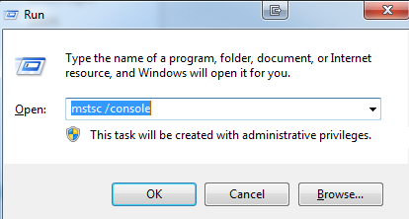

Start Eltima



Click on the site that has the fault, it will show the IP address of the device connected to the signals controller/connection status/data sending to site/data received from site/up time



Top right of Eltima click on edit:



Then edit the port in this example 4001.

Change to another number like 4002.



Click Apply changes

Then change back to 4001 again and Apply changes.

This should resolve most comms faults, if it does not contact:

Fusion but if it’s not one of their sites, it will be one of ICT fibre sites. In Eltima on the site list if it has an F after the site ID then this is a Fibre site = ICT / TCC site, call 5777028.

The software Eltima can be unresponsive and may need to be forced closed, if it does just restart Eltima again.

### Moxa/serial devices

Some site have serial devices (moxa or similar)

Type the IP address into internet Explorer (IE) as below, click restart.

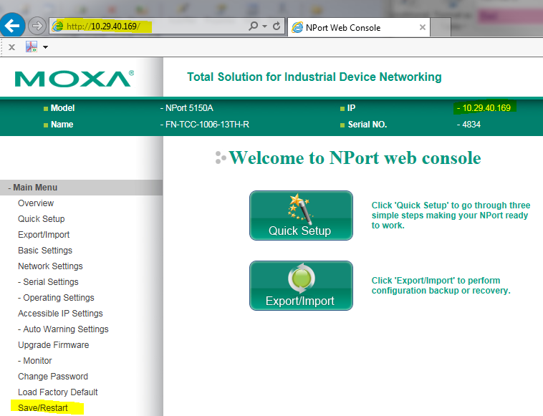

## Power Supply

In the case of losing power on particular sites, phone calls should be made to local power supplier (currently Trustpower on 0800 878787) at the first instance then the outcome should be reported to traffic signal contractor for their actions as appropriate.

ICP numbers are convenient for easy identifications and they can be viewable via site details in SCATS drop down menu.

# SCATS

## Notes in SCATS

If SCATS settings have been changed during the monitoring period, brief notes should be made to both message editors, we have two main areas for notes, **GUI Notes** under the graphics window with two lines available and **Site Notes**  - as shown below:

### **GUI Notes**: you can’t use “ctrl+T” for notes, therefore enter line as “Date, Initials – entry”



Top Line – for variations/action plans only – i.e. entered and deleted by the system, not a user. So do not use via manual method.

Bottom Line – Use for temporary changes especially to highlight operational changes, you can use the site notes for more details.

### **Site notes** have been divided up into three categories with headings on each panel:

Scats Operations – used for any scats operations other than linking/variations which are in the next panel

Variations, Linking, Co-ordination – List reasons why each VAR is used, ones that are skipped, any modifications.

Temporary Notes – Extension to the GUI notes line 2, mainly for day to day operations and temporary changes like Traffic Management.

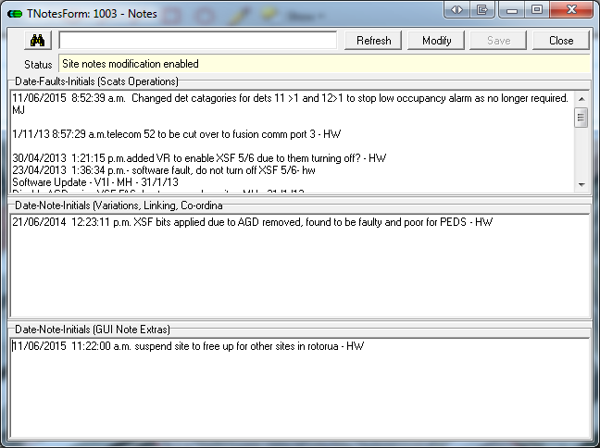

Once the changes have been reverted or more actions need to be taken, the old notes should be transferred to the Notes sections as shown below. Use “ctrl+T” at the start of line to enter time and date, be prescriptive, when changing values from say 1 to 5 document as 1>5 and explain why this is being done, for example “cyclist having difficulties being detected” or “slow moving logging trucks etc..”

## Software / CIS

### Standards for TTOC:

* 1.5 m/s ped walk speed
* All red phase for Scats dwell only
* Add MSS bits for inputs especially above ground.

### CIS > SCATS process

When new software completed put the files into the appropriate folders (see section 5.1) with “to be installed” until the site software is installed on site. Then move the current software and associated files into “OLD CIS”. Make sure the CIS has the checksum on the spreadsheet before it is sent to the contractor.

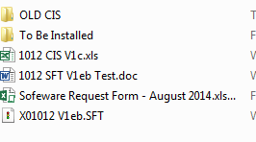

### Site Details

This area is useful for operators to identify specific setup for each site in relation to assets connected to the site and what they are and do. Therefore when a new software has been installed the site details need to be checked and entered into SCATS via the “edit>site details” on SCATS Access. The ICP number will be in the commissioning sheet in the site folder/asset/TTOC-07 SAT.

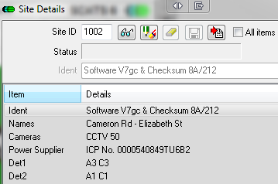

### Scats data

Check the Scats data is correct to the CIS:

* Site details, picture
* SA / SI, Links, Variations
* Add description in scats notes

# Documentation

## File structures

Site folders are in the Scats server \\tgascats normally labelled as Z drive (user defined)



Under sites, we have the individual numbers for each asset owner

* Tauranga City Council 1***
* Rotorua Lake Council 7018 and 7019
* NZTA 9*** , 8*** and 7*** (except the two RLC sites)

Copy and rename 0000 for a new site folder

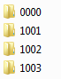

Tauranga Traffic Operations Centre