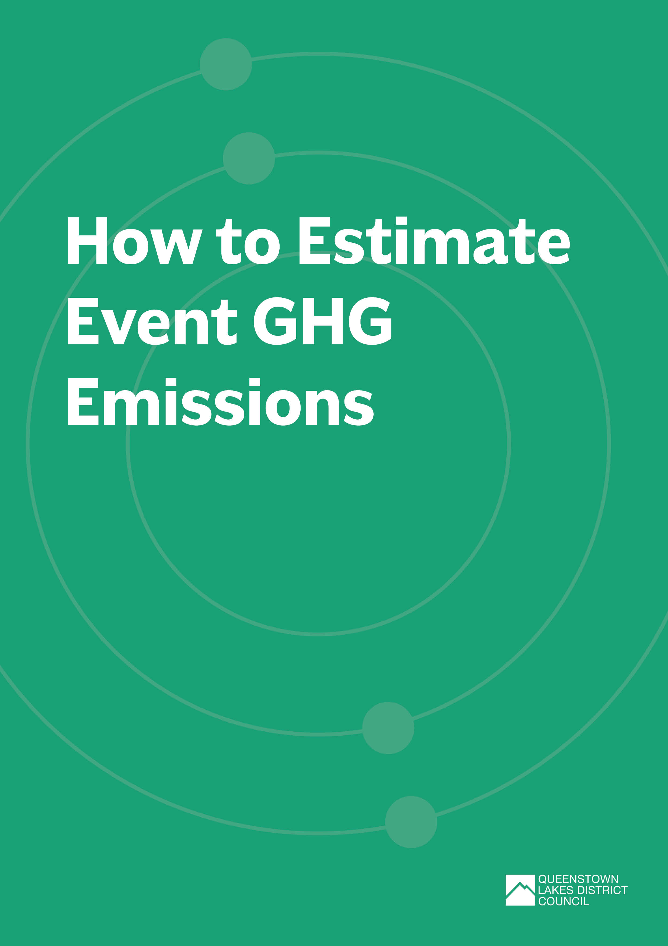

Introduction
Greenhouse gases (GHGs) are gases in the atmosphere which absorb infrared radiation from the sun, warming the Earth’s surface. These include carbon dioxide (CO₂), methane (CH₄), nitrous oxide (N₂O) and fluorinated gases. Naturally occurring GHGs enable life to exist on Earth. However, a significant increase in man-made sources since the Industrial Revolution has resulted in warming of the planet and changes to our climate.
New Zealand has made a commitment under the Paris Agreement to reduce net GHG emissions to 50% below 2005 levels by 2030, and achieve net zero GHG gases with the exception of biogenic methane, by 2050 (refer to the Climate Change Response Act 2002).
This means we all need to do our part in reducing GHG emissions. When you understand the sources and magnitude of your event’s GHG emissions, you can take steps to reduce them.
This document explains how you can estimate, report and reduce your event GHG emissions and outlines options for verification and certification.

Background to GHG emissions reporting
International best practice in GHG emissions estimation, verification and reporting should follow the principles of relevance, completeness, consistency, transparency and accuracy. It’s important to keep these principles in mind when estimating your event’s GHG footprint to ensure that it truly reflects the GHG emissions from your event. Two guidelines that standardise this approach are the GHG Protocol and International Standard ISO14064-1:2018.
GHG emissions can be grouped into:
- direct emissions - GHG emissions from sources owned or controlled by your organisation
- indirect emissions - GHG emissions generated by other sources as a result of your organisation’s activities.
The GHG Protocol categorises direct and indirect emissions into Scope 1, Scope 2 or Scope 3 (Figure 1), whilst the ISO14064-1:2018 standard categorises emissions into six categories where Categories 1 and 2 are equivalent to the GHG Protocol’s Scope 1 and 2. Examples of GHGs that may arise from events, and how they would be categorised are shown in Table 1.
Figure 1: GHG Protocol Scopes (Image source: GHG Protocol)
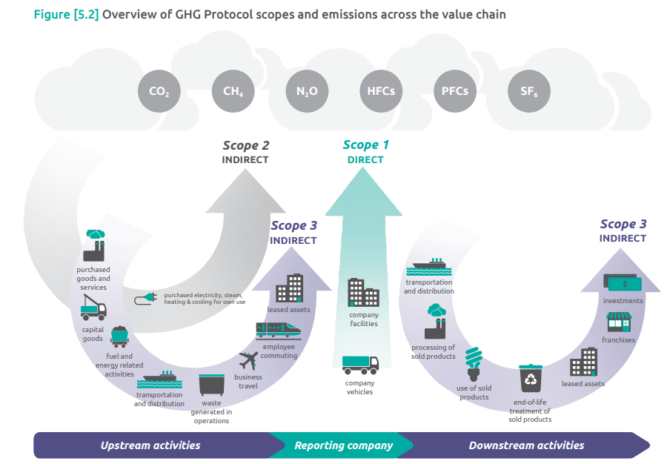

Table 1. Examples of event GHG emissions categories
GHG Protocol Scope |  | Description | Examples from events
Scope 1 |  | Stationary combustion | Diesel heating for a venue  On site diesel generator  LPG hot water  LPG cooktops  Fuel use for pyrotechnics
 |  | Mobile combustion | Petrol and diesel used in owned or leased vehicles
 |  | Leakage of refrigerants | Refrigerant leaks from fridges, freezers, air conditioning units
 |  | Land use change and forestry (emissions or removals) | Tree planting undertaken as part of an event
 |  | Fertiliser or lime use | Fertiliser used in grounds restoration by event organiser
 |  | Burning of organic matter | Bonfires
Scope 2 |  | Indirect emissions from imported electricity | Venue electricity use  Electric vehicle charging
Scope 3 | Cat 1 | Purchased goods and services | Vendor and supplier emissions  Emissions from event merchandise  Emissions from food sold at event
 | Cat 2 | Capital goods | Emissions from capital goods such as signage, reusable serveware, stage equipment
 | Cat 3 | Fuel and energy related activities | Energy transmission and distribution losses e.g.  - to get electricity or LPG to your site  - event attendee travel to site
 | Cat 4 | Upstream transportation and distribution | Freight of goods to site  Vendor, supplier and performer travel to site
 | Cat 5 | Waste generated in operations | Food and other organic waste sent to landfill  General waste to landfill
 | Cat 6 | Business travel | Hotel and transport by event organisers (e.g. event promotion)
 | Cat 7 | Employee commuting | Transport of volunteers and staff from home to the event site
Note: For more information refer to the MfE Guide on examples of Scope 1 and 2 emission sources (https://environment.govt.nz/assets/publications/Appendix-1-CNGP-guide.pdf)

How to prepare your event GHG emissions footprint

Detailed information on how to prepare a GHG emissions footprint is available in the Ministry for the Environment (MfE) Measuring emissions: A guide for organisations and includes the following steps:
- Select the organisational and reporting boundaries and the measurement period for the event.
- Identify your key emissions sources using Table 1 as a guide and collect activity data on each emission source.
- Calculate your event GHG emissions by multiplying the activity data by the correct emission factor for the reporting period.
- Prepare a GHG report that provides information about the organisation, how you developed your footprint, discusses significant changes in emissions from previous years (if applicable) and proposed changes to reduce emissions for the next event.

Top Tip: To make things easier you may wish to use an online spreadsheet such as the MfE Interactive Workbook.

3.1 Setting the boundaries for your footprint
Before defining your organisational and reporting boundaries, it’s important to understand why you’re preparing a GHG emissions footprint, what it will be used for, who will use this information, and the time period for measuring emissions. For example, will you estimate all emissions from commencement of organising the event to wrap up, or only from on-site set-up to event pack-down? Alternatively, for annual events you may wish to estimate emissions over a calendar year, or a financial year.
For most events, it will make sense to use an organisational control approach. In other words, calculate the GHG emissions from the event activities over which your organisation has control. This includes Scope 3 emissions from vendors and suppliers which your organisation selects for the event. For larger joint or collaborative events, you may want to take an equity share approach, which reflects your organisation’s financial interest in the event. For transparency it is good practice to report on how you defined your boundary and the justification for this decision.
The reporting boundary identifies the direct and indirect GHG emissions that you will be measuring. Use Table 1 to identify emissions sources relevant to your event. If you choose to exclude some sources, then provide an explanation of why they were excluded in your GHG report.
International best practices require all scope 1 and scope 2 emissions to be included in the emissions footprint, and only important scope 3 emission activities to be included. In selecting scope 3 activities start with the most significant emission sources, consider materiality, assess the relevance of other emission activities and justify why you have excluded other scope 3 emissions. Do not exclude significant sources if you are serious about reducing GHG emissions from your event. It is important to be open and transparent to avoid the risk of “green wash”.
TOP TIP: We recommend you start with GHG Protocol scope 1 and scope 2 emissions, and include scope 3 emissions Cat 1- 5
For more information on selecting the appropriate organisational and reporting boundaries refer to the GHG Protocol or ISO14064-1 Standard.
Specific guidance on selecting scope 3 emission activities related to events can be found in the Climate Active Carbon Neutral Standard for Events (Commonwealth of Australia 2020).

3.2 Collect activity data
Once you’ve identified the GHG sources you’ll be measuring, start collecting activity data. This may need to commence prior to the event. Activity data will include things like:
- volumes, weight or energy units of fuel
- electricity meter readings to measure kWh
- distance travelled
- volume or weight of waste to landfill by different waste streams
It is good practice to develop a data management plan, which should include roles and responsibilities, your methods for collecting activity data, record keeping requirements and quality control procedures. This is of particular value for recurring events, so that consistent data collection and management can be done year on year, and progress towards emission reductions can be tracked. Data management plans should also address existing data gaps and how these will be improved in the future.
Measured data should be used whenever possible, with conservative estimates used only where data is unavailable. For example, operational energy data should be obtained from meter readings shown on your utility bills. Where estimates are used, they must be appropriately justified with respect to data availability and the relative size and nature of the estimated emission source.
Table 2: Example data collection methods
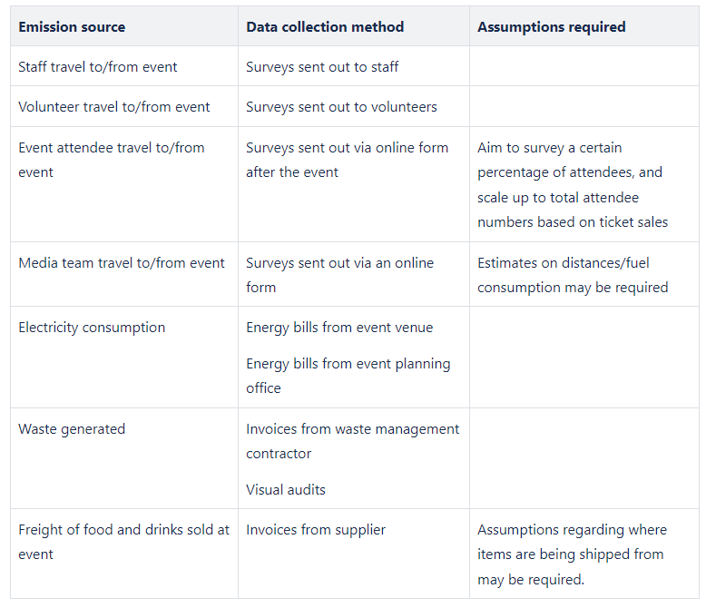

Enter the activity data into your spreadsheet. The MfE Interactive Workbook will have pre-loaded options to select the appropriate activity units. However, it does not cover all Scope 3 emissions. If you don’t have detailed information for Scope 3 emissions you can use the spend to estimate GHG emissions from a particular activity. Emission factors based on spend are available for a range of purchased goods and services in Market Economics (2023).
In addition to activity data, you may also want to collect qualitative data before, during or after your event (e.g. volunteer or customer feedback, stakeholder involvement, data collection processes/challenges/successes).

3.3 Calculate GHG emissions
GHG emissions are calculated using the activity data multiplied by an emission factor. For example, if 100 litres of diesel were used in a generator on-site during the event, multiply this volume by an emission factor for stationary diesel of 2.69 kg CO₂e per litre, to calculate the GHG emissions from this activity:
100 L x 2.69 = 269 kg CO₂e (or 0.269 tonnes CO₂e)
Once you have entered the activity data, it’s important to check that you have the most up to date emission factor for the time period selected. Emission factors are provided by the Ministry for the Environment and are updated regularly.
Different GHGs have different global warming potential. To enable comparison of different gases, emissions are expressed in units which compare the global warming potential of a particular gas with the global warming potential of carbon dioxide. For example, methane has a global warming potential 28 times greater than carbon dioxide over 100 years, and therefore 1 tonne of methane would be expressed as 28 tonnes carbon dioxide equivalent (CO₂e). The MfE emission factors take into account what GHGs will be emitted from certain activities, and the global warming potential of these gases.
If you’re using the MfE Interactive Workbook emission factors have already been entered in the spreadsheets and the calculation should be automatic.
Once you have calculated your GHG emissions, analyse the results.
- What are the largest sources of emissions?
- What can you do about them?
- Are there GHG emissions that can be easily eliminated or reduced next time?

3.4 Prepare a GHG report
A report is useful for explaining how you prepared your GHG footprint, any exclusions or assumptions made, summarising the results and outlining where emission reductions could be made in the future. It should be consistent with the intended use and users of the GHG footprint. You may choose to prepare a simple report to share your story, or a more detailed report that meets verification and certification requirements. A detailed GHG report should include as a minimum:
- A description of your organisation, the event, and the time period for the GHG footprint;
- Organisational boundary;
- Reporting boundary;
- Description of methodology and activity data used including any exclusions, assumptions, uncertainties or inaccuracies;
- Summary of the results of the GHG footprint, and any trends if emissions have been estimated in previous years.
Top Tip: If you are contracting a third party to produce the event GHG footprint they can provide a GHG report for you. This should be made clear in the contract if this is a service you’d like to include.
Refer to the GHG Protocol or ISO14064-1 Standard for detailed reporting requirements.
Refer also to the Communications and Engagement Plan Template for tips on sharing your event’s GHG emission reduction journey.

Preparing an Emissions Reduction Plan
Calculating your emissions footprint is an important first step in creating an emission reduction plan, as it will highlight which high-emitting activities you should focus your emission reduction efforts on. Whilst an emissions reduction plan is not typically part of an emissions footprint, it will be required for any ‘carbon neutral’ certification programme.
Your emissions reduction plan should include specific measures to be undertaken and the quantity of emissions to be reduced over a particular timeframe and may include commitments to activities such as:
- increasing energy efficiency (e.g. by installing energy efficient lighting and appliances),
- switching to renewable energy sources (could you have on-site solar panels to generate electricity for your event?),
- using less emissions intensive products (e.g. switching from fuel to electric/hybrid vehicle fleets),
- changing practices to replace emissions intensive activities with those that generate fewer emissions (e.g. reducing flights to business meetings through using teleconferencing, providing carpooling services, encourage public transport for your event attendees),
- responsible treatment of waste (e.g. zero-waste strategies, improved recycling opportunities),
- working with suppliers that have a better sustainability record (e.g. a media team that has an EV fleet, source event food/beverages locally so that freight emissions are reduced).

Verification and certification

If you want to make a claim about your event’s GHG emissions (e.g. “net zero carbon” event) or if you’d like assurance of the accuracy of your GHG footprint, then you will most likely be required to engage a third party to audit and verify your emissions footprint.
Typically, auditors will use the “GHG Protocol: Corporate Accounting and Reporting Standard”, or “ISO 14064-1:2018 Specification with guidance at the organisation level for quantification and reporting of greenhouse gas emissions and removals”.
Carbon programmes and certifications available in New Zealand include:
- Carbon Conscious, Carbon Reduce –measure and reduce GHG emissions
- Net Zero Carbon, Carbon Neutral – measure, reduce and offset 100% GHG emissions
- Climate Positive - measure, reduce and offset 120+% of GHG emissions against best practice science-aligned targets
To achieve certification for your event you will need to follow these steps (Figure 2).

Each of the certification programmes have specific measurement, reporting and disclosure requirements. Some types of certification, such as ‘carbon neutral’ or ‘carbon positive’, will require the use of offsets in order to eliminate any remaining emissions in your emissions footprint (remember, the first priority is that you reduce emissions).
If you select a carbon certification programme that includes offsets, you will need to purchase verified carbon credits that meet international standards. However, even if you’re not participating in a carbon certification programme, you could still offset your GHG emissions if desired. This could be done directly, by purchasing certified carbon credits or by introducing carbon removal opportunities within your supply chain, or indirectly by contributing to local revegetation projects.

(BREAKOUT)
How to eliminate those remaining emissions
Carbon sequestration, or removal of GHGs from the atmosphere, should only be considered once your organisation has made all efforts to first reduce GHG emissions for your event. Options include:
- Voluntary carbon offsets – These are purchased carbon credits for sequestration outside the boundary of your organisation. For carbon offsets to be considered credible they must be real, measurable, verified, additional (to business as usual or what is currently present), permanently protected, not double-counted, address leakage (i.e. not result in emissions elsewhere) and be transparently reported. For more information refer to the MfE Guidance for Voluntary Carbon Offsetting.
- Investing in renewable energy or sequestration projects to mitigate GHG emissions produced by your organisation and/or supply chain.
- Local planting projects – Whilst local planting projects may not meet the requirements for offsetting to achieve certain types of certification, there are benefits to restoring local indigenous ecosystems which will aid in the sequestration of GHG emissions and enhance local biodiversity. You may opt to fund and organise your own local planting project, or contribute to organisations within the district that undertake this important work. Whilst this type of support may not be quantitatively reflected in your GHG emissions footprint, we still recommend supporting such initiatives and reporting if you do so. If you wish to make a carbon claim such as being a “Net Zero Carbon Event” then local planting projects may not meet the international standards for verified carbon credits, and may not be appropriate for this purpose.
Refer to the Supplier Directory for contacts to assist with auditing, verification, certification and carbon sequestration.

Further Resources
Further resources to help you estimate, report and reduce your event GHG emissions are provided below. See also the Supplier Directory for contacts to assist with estimation, auditing, verification, certification and carbon sequestration.
BRITISH STANDARDS INSTITUTION
International standards website to purchase PAS 2060 ‘Carbon Neutrality Standard’.
CLIMATE ACTION TOOLBOX
Understand where and how you can reduce emissions, estimate your carbon footprint, build an emissions reduction plan.
CLIMATE ACTIVE CARBON NEUTRAL STANDARD FOR EVENTS
A voluntary standard providing best-practice guidance on how to measure, reduce, offset, validate and report emissions that occur as a result of an event (Commonwealth of Australia, 2020).
GENLESS AND FUTURE FIT
Discover your impact on the planet, understand how your daily actions can make a difference and tips to take action.
GREENHOUSE GAS PROTOCOL
International standards, guidance and calculation tools to measure and manage GHG emissions.
INTERNATIONAL STANDARDS ORGANISATION
International standards website to purchase ISO 14064-1:2018 ‘Specification with guidance at the organisation level for quantification and reporting of greenhouse gas emissions and removals’ and ISO 20121:2012 ‘Sustainable Events’.
MINISTRY FOR THE ENVIRONMENT: OUR CLIMATE FUTURE
Actions we can take individually or collectively to reduce our impact on the planet.
MINISTRY FOR THE ENVIRONMENT: MEASURING EMISSIONS
Summary and detailed guides for organisations to measure emissions, current Emission Factors and links to the Interactive Workbook to calculate your GHG footprint.
NET ZERO CARBON EVENTS
An initiative to move the event industry towards net zero carbon emissions, with a quick guide to getting started.
SUSTAINABLE BUSINESS NETWORK
Tools and resources to learn and take action in key areas including climate, waste and nature restoration.
TOITŪ MEMBER GUIDE
The Toitū Members Guide provides examples of events that have been certified and their emissions boundary, disclosure of exclusions, quantification of emissions, and emission reduction plans.

The PAS 2060 - Carbon Neutrality Standard and Certification and the ISO 20121:2012 for Sustainable Events are other standards that could be considered, although the latter addresses more than just GHG emissions.

