Upper Clutha Wastewater Conveyance Scheme

Kia ora and hello,
We are writing to update you about upcoming works taking place near your residence or business over the coming weeks.
Queenstown Lakes District Council (QLDC) and Fulton Hogan are upgrading Upper Clutha’s wastewater network, which will ultimately increase the capacity and resilience of Hāwea, Albert Town, and Wānaka’s wastewater systems, and minimise the chance of contaminants entering the natural environment.
The next stage of our work involves installing pipe from the Albert Town bridge through to the Mount Iron roundabout. The pipe will be installed within the road reserve alongside State Highway 6 from Kingston St and will head south from here, moving towards the Mount Iron roundabout (see map overleaf).

What to expect in the coming weeks near your property
From next week, you may notice sections of pipe being delivered to locations along State Highway 6. The next step is to weld the pipe together into longer strings. This work is done in an enclosed mobile trailer, ensuring this process is safe and noise is kept to a minimum. Trenches will be dug and the welded pipe strings will be placed in the trenches and then backfilled.
With any large construction project, there will be additional noise, vibration, and construction machinery movements near the worksites where pipes are being installed.
Traffic Management
Construction crews will largely work under shoulder closures with possible temporary speed limits in place. In some instances, where the width of the road reserve is narrow, stop/go may be required to ensure the safety of our crews and road users.
Resident access
The alignment of the pipeline crosses side roads and driveways. Our crews will be in contact with residents and property owners to coordinate times and minimise disruption as much as possible.
Tree removal
Several trees on the road reserve and overhanging tree limbs will need to be removed to allow the installation of the wastewater pipeline. Our crews will be in contact with impacted residents prior to the removal of these trees/limbs.
Pedestrian and cyclist access to road reserve
To ensure the safety of pedestrians and cyclists during construction works, sections of the road reserve may be closed to the public. Where possible, detours will be in place around the construction site. Please take care if you pass by the construction site.
Possibility of night work
In some complex areas along the pipe alignment, such as steep sections, short periods of night works may be required to install the pipe as quickly as possible and to minimise traffic disruptions. We will provide more information once details are confirmed.
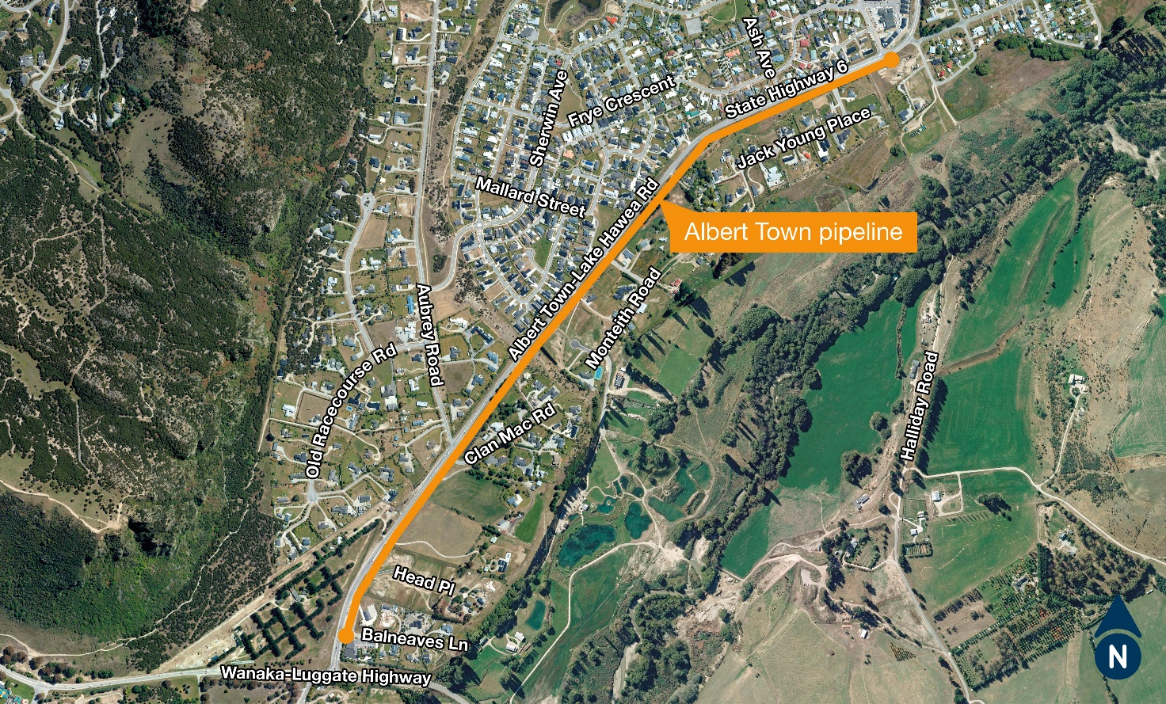
The stretch of pipeline being installed alongside SH6 between Albert Town Bridge and Mt Iron Roundabout.
Albert Town Bridge
The pipe will need to be installed across the Albert Town Bridge. To do this work, bridge closures will be required. The project team is currently working through plans for how best to do this with the minimal closures required, while ensuring the pipeline can be installed safely. Further details will be provided over the coming weeks.

What else is happening as part of the upgrades?
Upgrades to Upper Clutha’s wastewater network started in September last year and include:
- Construction of a new wastewater pump station at Domain Road in Hāwea.
- Installation of over 20km of a new wastewater pipeline between Hāwea, Albert Town, Riverbank Road in Wānaka, and Project Pure Wastewater Treatment Plant.
- Upgrades to the existing Riverbank Road Wastewater Pump Station.
- Upgrades to the Project Pure Wastewater Treatment Plant inlet.
- Decommissioning of the Hāwea treatment plant once the township’s wastewater is being conveyed to Project Pure.
QLDC and Fulton Hogan are making steady progress to meet the project completion date of early 2027.
More information
To sign up to our newsletter and find more information on the Upper Clutha Wastewater Conveyance Scheme visit www.qldc.govt.nz/upper-clutha-ww. If you have any questions, comments, or concerns, please contact QLDC’s Services team by phone on 03 441 0499 or email at services@qldc.govt.nz.

Thank you for your patience while this important work is carried out.

