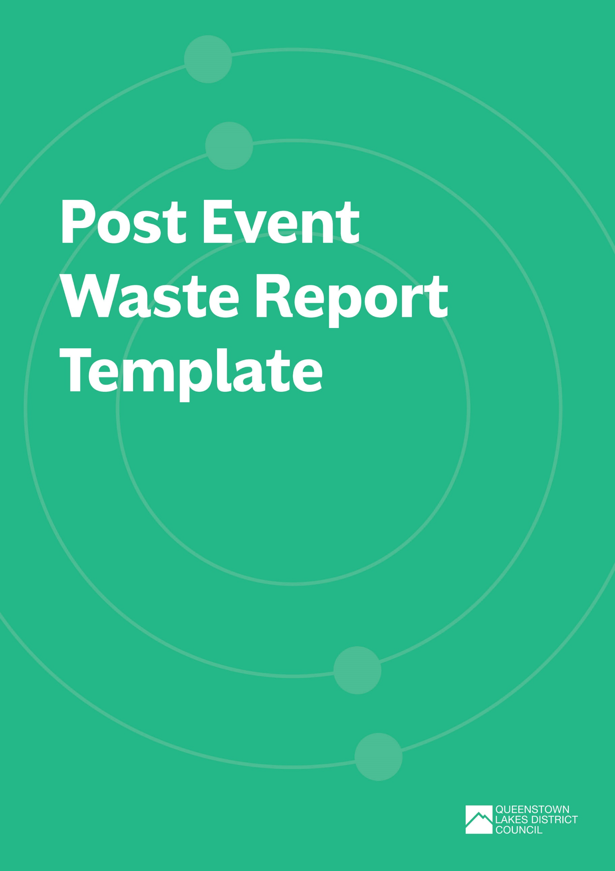
Post Event Waste Report
For further information or assistance with completing the Post Event Waste Report, refer to the Event Waste and Emissions Reduction Guide or contact zerowaste@qldc.govt.nz.
Please submit the completed report and any supporting documents to the QLDC Waste Team (zerowaste@qldc.govt.nz) no later than 28 days following the event finish date.
REVIEWER DETAIL (FOR QLDC USE ONLY)
rEVIEWER:
dATE:
GENERAL FEEDBACK:

Event Overview
EVENT DETAILS
Event title:
EVENT ORGANISER:
kEY CONTACT (name & role):
eMAIL:
pHONE:
Type of event:
Location:
Date(s) of event
Pack in:
Event start:
Event finish:
Pack out:
number of attendees:
Event activities:
Number of food and beverage vendors:
Number of marketplace/ merchandise vendors:
WASTE AND MATERIALS DATA – WHAT WAS MEASURED
WASTE DATA
MATERIAL /  WASTE STREAM | AMOUNT (WEIGHT OR VOLUME) | COLLECTION CONTRACTOR | MATERIAL DESTINATION
Choose an item. |  |  | Choose an item.
Choose an item. |  |  | Choose an item.
Choose an item. |  |  | Choose an item.
Choose an item. |  |  | Choose an item.
Choose an item. |  |  | Choose an item.
Choose an item. |  |  | Choose an item.

was waste sorted and/or audited? | ☐ | yes – please provide detail/audit report
was waste sorted and/or audited? | ☐ | no
were there issues with contamination of recycling / composting streams | ☐ | YES – PLEASE PROVIDE DETAIL
 | ☐ | NO

TOTAL AMOUNT OF MATERIAL GENERATED BY THE EVENT (WEIGHT)
TOTAL AMOUNT OF MATERIAL NOT SENT TO LANDFILL (EG. RECYCLING, COMPOSTING, REPURPOSING, DONATING) (WEIGHT)
DIVERSION (%)
= NON-LANDFILL WEIGHT / TOTAL MATERIALS WEIGHT X 100
WAS THE DIVERSION TARGET ACHIEVED?  (AS SET IN EVENT WASTE MINIMISATION AND MANAGEMENT PLAN) | ☐ | YES
 | ☐ | NO
AVOIDANCE
HOW MUCH WASTE WAS AVOIDED BY USING REUSABLE SERVEWARE?
FEEDBACK ON AMOUNT AND TYPE OF WASTE GENERATED, DIVERTED AND AVOIDED?

eg. WERE THERE ANY WASTE STREAMS GENERATED THAT HADN’T BEEN EXPECTED? WERE THERE SINGLE USE ITEMS THAT COULD HAVE BEEN AVOIDED?

TRACKING OF OBJECTIVES (AS SET IN EVENT WASTE MINIMISATION AND MANAGEMENT PLAN)
OBJECTIVE | WAS OBJECTIVE ACHIEVED? | WHY / WHY NOT?

FEEDBACK (FOR QLDC USE ONLY):

REFLECTION AND LESSONS LEARNED
What WORKED WELL AND WHAT COULD BE IMPROVED in relation to waste systems and processes
SOME AREAS FOR CONSIDERATION:
- WASTE, RECYCLING AND REUSE INFRASTRUCTURE AND LOGISTICS
- EVENT LAYOUT
- SIGNAGE
- STAFFING
- VENDOR PARTICIPATION
- PUBLIC PLACE BIN MANAGEMENT
- FEEDBACK received

FEEDBACK (FOR QLDC USE ONLY):

What WORKED WELL AND WHAT COULD BE IMPROVED in relation to stakeholder communication and engagement
SOME AREAS FOR CONSIDERATION:
- UPTAKE OF key messages
- communicaTION CHANNELS
- BEHAVIOUR AND ATTITUDE
- FEEDBACK received
- DIFFERENCES ACROSS STAKEHOLDER GROUPS

FEEDBACK (FOR QLDC USE ONLY):

