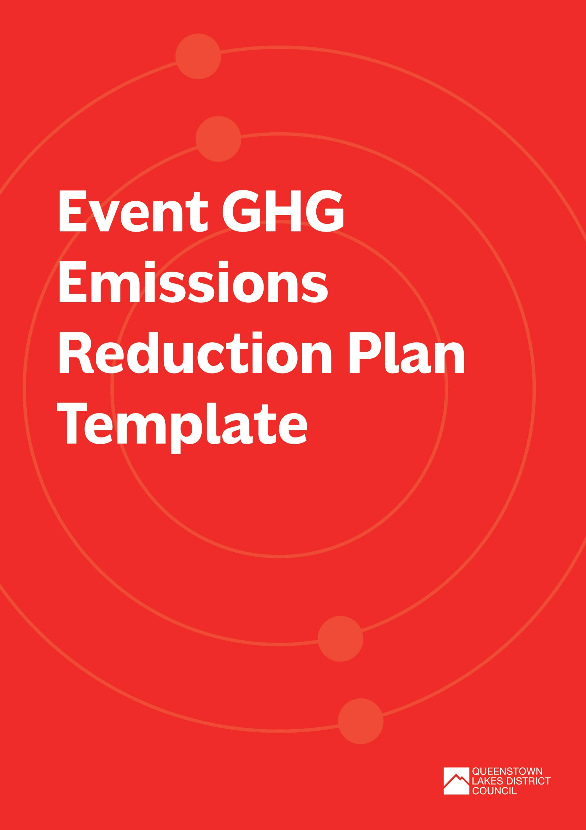

Event GHG Emissions Reduction Plan Template
Use this template to help you set objectives and targets with your actions and planning requirements for reducing your event’s GHG emissions.
Before you start, make sure you read through the Event Waste and Emissions Reduction Guide and the supporting document on How to Estimate Event GHG Emissions. This will help you to estimate your event’s GHG emissions to understand your key emission sources.
The template is broken into the following sections:
- Event overview – if you have completed the Event Waste Minimisation and Management template, you can use the same details here
- Identifying your key GHG emission sources, or plans to collect emission data
- Emissions reduction objectives, targets, success indicators and supporting initiatives
- Detail of emissions reduction initiatives

How to use this template:
Complete each section below. You can add or remove rows in the tables as needed. We’ve provided some prompts and examples in greyed out text, just delete these as you work through your plan.

Event Overview
EVENT DETAILS
Event title: |  | Title of event/ official name of the event that will be referred to on any applications
Type of event: |  | E.g.:  - Arts / Cultural (Outdoor Exhibition or Performances)  - Entertainment (Music Festival, Circus, Concert)  - Community Event (School Fair / Gala Day, Fundraiser)  - Sports (Marathon, Cycle Race, Water Sports)  - Market (Craft Market, Food Market, Farmers Market)
Location (attach or insert map if possible): |  | Venue name, location and description
Date(s) of event: |  | Pack in:
 |  | Event start:
 |  | Event finish:
 |  | Pack out:
Time of live event: |  | Start time:
 |  | Finish time:
Estimated number of attendees:
Name of organisation delivering the event: |  | Lead organisation hosting the event
Event activities: |  | List the activities that will take place during the event. E.g., entertainment (music, performers), food and beverage, merchandise stall, marketplace, workshops, kids’ activities etc.
Number of food and beverage vendors:
Number of marketplace/ merchandise vendors:
CONTACT DETAILS
Name:
Organisation:
Role in the event/ responsibility: | E.g., lead event manager
Phone number:
Email Address:

Estimate your Emissions
Things to consider | Provide details
Is this the first year for your event? | ☐ | Yes
 | ☐ | No
Have you estimated your event’s GHG footprint? Please select which option applies. | ☐ | Yes. We have estimated the GHG footprint based on previous year’s data. Our three largest emission sources will be:
 | ☐ | Yes. We have estimated the GHG footprint based on a similar event. Our three largest emission sources will be:
 | ☐ | No. But we have a plan to collect data on:  - (Please outline what data you’ll be collecting)
 | ☐ | No. We do not plan to collect data for this event.  - (Please state why)

Emissions objectives, targets and success indicators
Based on your GHG footprint, list the objectives and targets you have identified to reduce GHG emissions and/or improve data collection for your event. Identify how you will measure success and what initiatives you will implement to achieve your objectives and targets.
OBJECTIVES | TARGET | HOW WILL YOU MEASURE SUCCESS? | INDICATORS FOR SUCCESS | SUPPORTING INITIATIVES
E.g., To reduce transport emissions from vendors and suppliers | E.g., 95% of suppliers and vendors are sourced from within the district | E.g., Supplier and vendor contact list | E.g., Contact list shows that 95% of suppliers and vendors are based within the district | E.g., Sustainable Procurement Policy
E.g., To reduce energy use during the event | E.g., Reduce venue electricity use by 20% from the previous year | E.g., Electricity meter readings | E.g., Electricity meter readings show a reduction in electricity use by at least 20%. | E.g., Working with venue manager to optimise lighting and heating/ cooling settings and switch off lights and appliance when not in use.
E.g., To reduce transport emissions from staff and volunteers between event locations | By [insert year], reduce GHG emissions calculated from staff and volunteer travel between event locations by 90%. | E.g., Calculate GHG emissions from distance travelled between locations and mode of transport | E.g., Calculated GHG emissions from staff and volunteer travel between event locations have reduced by 90% | E.g., Transport initiatives (Cargo e-bikes, EV hire, carpooling, shuttlebus transport)

Emission Reduction Initiatives
Identify which of the GHG emissions reduction initiatives you have selected for your event. Review the GHG Emissions Reduction checklist as a guide and include any other initiatives you have identified.
Initiative | Detail of what’s proposed | Who will be implementing?
E.g., Choose a location that is easily accessible by public transport, biking or walking | E.g., The event will be based in Arrowtown with the race start/finish line at Butlers Green. All participants and spectators can walk between event activities and there is a public bus route that services Arrowtown.  Event organiser will liaise with Otago Regional Council to provide additional buses during expected peak times | - Trust has selected event location  - Event manager to liaise with Orbus to manage anticipated public transport patron numbers
E.g., Secure on-site bicycle parking to encourage cycling to event | E.g., A secure bike parking area will be set up at the centre of the event. Security will be ensured by giving cyclists a unique reference number to identify their bike, which will be parked in a fenced, staffed area. | - Paid staff to monitor secure bike parking area between gate opening and closing times.
E.g., Estimate attendee travel GHG emissions to incorporate 100% offset of these emissions in the ticket price. | E.g., From previous year’s “How did you get here?” survey, estimate attendee travel GHG emissions. Include cost of purchasing 100% offset of emissions in this year’s ticket price.  The Communications Plan will promote our emissions reduction objectives and targets and explain why we’ve opted to include offsets in the ticket price. | - Sustainability manager to estimate attendee travel GHG emissions from last year’s survey and calculate offset purchase cost to incorporate into ticket price.  - Purchase offsets through organisation which ensure they meet international best practice such as additionality and permanence requirements.
List any other initiatives  E.g., Provide the option to donate to local tree planting projects on ticket purchase | E.g., Provide links to local not-for-profit local tree planting projects on ticket purchase to enable attendees to provide a voluntary donation. | - Event manager to liaise with local not-for-profit biodiversity organisations for permission to promote donation details on ticketing website.  - Event manager to work with ticketing platform to enable donations during ticket purchase.

Sharing your message
Share your GHG emission reduction goals, objectives, targets and initiatives with your stakeholders including suppliers, vendors and event attendees. Make sure you communicate how they can help you achieve these. A Communication Plan will help you formalise how you share your message with stakeholders.
Have you developed a Communication Plan to help raise awareness of your GHG emission reduction initiatives? You can use the Communication and Engagement Plan Template as a guide. | ☐ | Yes
 | ☐ | No

Tracking Success
How will you track the success of your GHG emission reduction initiatives? Refer How to Estimate Event Greenhouse Gas Emissions for more information.
E.g., We will be measuring our Scope 1, Scope 2 and Scope 3 (transport and waste related) GHG emissions from this year’s event, to compare with last year and identify areas of improvement for future events.

Post Event
Use the post event template below to help you review your key emissions sources, effectiveness of emission reduction initiatives, stakeholder engagement and other learnings. We’ve provided some prompts and examples in greyed out text which can be deleted.
Things to consider |  |  | Provide details
Did you measure your GHG emissions, and if so, what were your key emission sources? | ☐ | Yes | Provide key emission sources
 | ☐ | No | If no, why?
What initiatives will you consider to reduce key emission sources at future events?
How engaged were people with your emission reduction initiatives? | Staff/ Volunteers |  | E.g., Very. All staff and volunteers attended the pre-event training
 | Suppliers/ vendors |  | E.g., Very. Suppliers and vendors were selected based on their ‘green credentials’
 | Attendees |  | E.g., Somewhat. Next year our Communication Plan will focus on attendees to better explain our GHG emission reduction journey
Did you achieve your GHG emission reduction targets? | ☐ | Yes | If yes, highlight wins
 | ☐ | No | If no, what did you learn?
Any other learnings or improvements proposed?
(INSERT - How to Estimate Event Greenhouse Gas Emissions Guide here)
NEED FURTHER SUPPORT?
For further information or assistance with your GHG Emissions Reduction Plan, please contact the Queenstown Lakes District Council at climateaction@qldc.govt.nz

