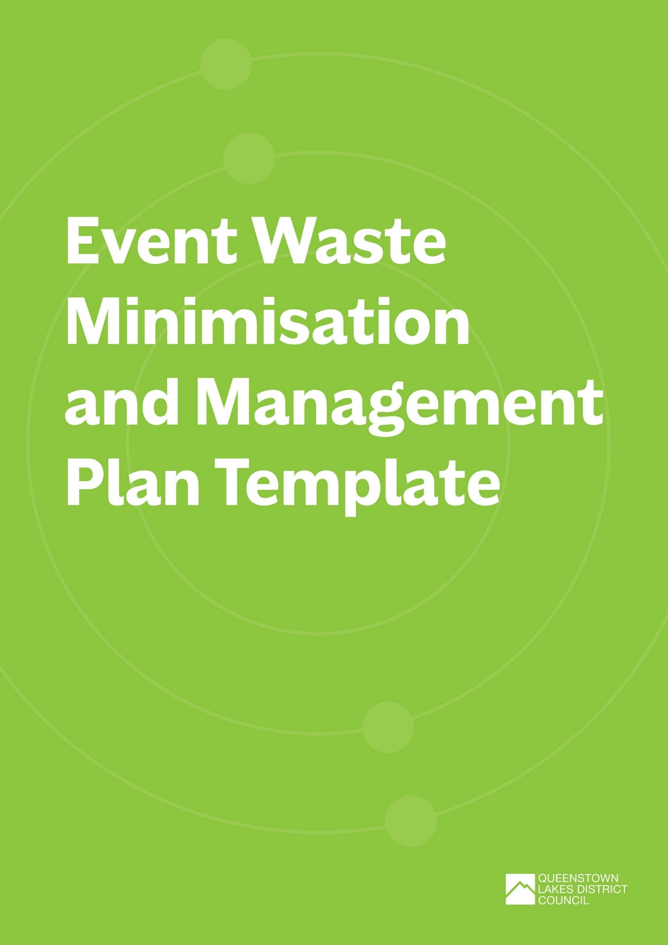
Event Waste Minimisation and Management Plan
For further information or assistance with completing the Event Waste Minimisation and Management Plan, refer to the Event Waste and Emissions Reduction Guide or contact zerowaste@qldc.govt.nz.
Please submit the completed plan and any supporting documents to the QLDC Waste Team (zerowaste@qldc.govt.nz) at least 28 days prior to event start date.

REVIEWER DETAIL (FOR QLDC USE ONLY)
rEVIEWER:
dATE:
GENERAL FEEDBACK:

Event Overview
EVENT DETAILS
Event title:
EVENT ORGANISER:
kEY CONTACT (name & role):
eMAIL:
pHONE:
Type of event:
Location:
Date(s) of event
Pack in:
Event start:
Event finish:
Pack out:
Estimated number of attendees:
Event activities:
Number of food and beverage vendors:
Number of marketplace/ merchandise vendors:

WHO ELSE WILL BE ASSISTING WITH EVENT WASTE MINIMISATION AND MANAGEMENT?
WHO | DETAIL
Volunteers
Paid Staff
Contractors
Other (please specify)

FEEDBACK (FOR QLDC USE ONLY):
Event waste PROFILE – WHAT WASTE WILL BE CREATED?
WASTE PROFILE
MATERIAL /  WASTE STREAM | SOURCE | STAGE | COLLECTION CONTRACTOR | MATERIAL DESTINATION
Choose an item. |  | Choose an item. |  | Choose an item.
Choose an item. |  | Choose an item. |  | Choose an item.
Choose an item. |  | Choose an item. |  | Choose an item.
Choose an item. |  | Choose an item. |  | Choose an item.
Choose an item. |  | Choose an item. |  | Choose an item.
Choose an item. |  | Choose an item. |  | Choose an item.

FEEDBACK (FOR QLDC USE ONLY):

EVENT WASTE BINS and Equipment – MANAGING AND collecting THE WASTE
WASTE BINS AND EQUIPMENT
MATERIAL /  WASTE STREAM | TYPE (BIN / SKIP & SIZE) | QUANTITY | STAGE | LOCATION | SUPPLIER
 |  |  | Choose an item. | Choose an item.
 |  |  | Choose an item. | Choose an item.
 |  |  | Choose an item. | Choose an item.
 |  |  | Choose an item. | Choose an item.
 |  |  | Choose an item. | Choose an item.
 |  |  | Choose an item. | Choose an item.

WILL REUSABLE SERVEWARE BE USED AT THE EVENT?
☐ | NO – WHAT IS THE MAIN REASON?  (EG. COST, INFRASTRUCTURE, KNOWLEDGE, TIME)
☐ | YES – PLEASE ANSWER THE FOLLOWING:

WHAT TYPE OF REUSABLE SERVEWARE WILL BE USED AND HOW MANY OF EACH WILL BE AVAILABLE?
Where will reusable serveware be available during the event? | ☐ | At the point of sale with vendor/stallholder
Where will reusable serveware be available during the event? | ☐ | At designated collection point(s) – please specify:
Where will reusable serveware be available during the event? | ☐ | Other – please specify:
Will a bond system be used for reusable serveware? | ☐ | Yes
Will a bond system be used for reusable serveware? | ☐ | No
Will a bond system be used for reusable serveware? | ☐ | Other – please specify:
How will reusable serveware be RETURNED AFTER USE? | ☐ | Returned to vendor/stallholder
How will reusable serveware be RETURNED AFTER USE? | ☐ | Designated drop-off point(s)
How will reusable serveware be RETURNED AFTER USE? | ☐ | Other – please specify:
HOW WILL REUSABLE serveware be washed and sterilised for reuse?

management
HOW WILL BINS BE MONITORED AND MANAGED DURING THE EVENT?
WHAT ACTIONS WILL BE TAKEN TO PREVENT CONTAMINATION OF RECYCLING / COMPOSTING BINS?
HOW WILL VENDOR WASTE BE MANAGED?
Are there qldc public place rubbish and recycling bins on the event site? | ☐ | Yes – please provide detail of how these will be managed (note. Council waste contractor must be notified of any impact to servcing schedule and bins should be either covered or event RESPONSIBLE FOR empty and clean at pack out)
 | ☐ | NO
How will litter at THE event site be managed?

FEEDBACK (FOR QLDC USE ONLY):

measuring impact
MEASURING
HOW WILL WASTE BE MEASURED?
WILL A WASTE SORT AND/OR AUDIT BE CONDUCTED? | ☐ | YES – PLEASE PROVIDE DETAIL
WILL A WASTE SORT AND/OR AUDIT BE CONDUCTED? | ☐ | NO
DIVERSION TARGET (%)
= NON-LANDFILL WEIGHT / TOTAL MATERIALS WEIGHT X 100

THE PROPORTION OF TOTAL AMOUNT OF MATERIAL GENERATED BY THE EVENT THAT CAN BE KEPT OUT OF LANDFILL THROUGH OTHER METHODS OF THE WASTE HIRERACHY (EG. RECYCLING, COMPOSTING, REPURPOSING, DONATING)
SETTING OBJECTIVES
Setting objectives for managing and minimising event waste helps to understand environmental impact, track improvement, identify targets, outline the actions needed to achieve them, and measure delivery success.
Objectives should be SMART:
- Specific (clear and focused)
- Measurable (you can track progress)
- Achievable (realistic to accomplish)
- Relevant (meaningful to your event)
- Time-bound (has a deadline).
reporting back on these objectives will be requested in the post event waste report
OBJECTIVE | ACTION/S TO ACHIEVE OBJECTIVE

FEEDBACK (FOR QLDC USE ONLY):

COMMUNICATION AND ENGAGEMENT
HOW WILL THE EVENT WASTE MINIMISATION AND MANAGEMENT BE COMMUNICATED WITH STAKEHOLDER GROUPS AND WHAT ARE THE KEY MESSAGES? Use the Communications and Engagement Plan Template as a guide.
ATTENDEES
VENDORS
STAFF & VOLUNTEERS
CONTRACTORS
SPONSORS
media
General Public
OTHER

FEEDBACK (FOR QLDC USE ONLY):

SITE LAYOUT
Please attach site LAYOUT OR insert below.
this should include (where applicable):
- FRONT OF HOUSE Waste stations, including rubbish and recycling bins together
- Back of house waste hub, waste sorting, or storage facilities
- Signage
- Drinking water sites
- Drop off points for reusables
- Food/drink vendors and preparation areas
- Merchandise/market vendors
- Entertainment sites/stage location
- Entrances and exits
- Toilets and toilet blocks
- Any QLDC public rubbish and recycling bins

FEEDBACK (FOR QLDC USE ONLY):

